Every organization, whether it knows it or not, has a particular set of core values that define every aspect of their daily decisions, from how they answer messages from donors on Facebook to how employees are rewarded.
Without clearly defined core values, an organization lingers in a constant state of an identity crisis. Worse yet, the organization then operates on some values but it just doesn’t know which ones.
Therefore, a process by which a nonprofit organization determines its core organizational values is invaluable.

What Are Nonprofit Organizational Values?
Nonprofit organizational values are the highest values that guide an organization’s actions, unite its employees, and define its brand. They are abstract ideas that guide organizational thinking and actions. These guiding principles are typically communicated in writing as core values and statements.
Organizational values are ideally set as part of strategic planning when an organization is just being set up (alongside a mission and a vision). If you have already been running your nonprofit for months or even years without identifying core organizational values, no worries. You can (and should) still determine them!
Note that at times, nonprofit mission, vision, values, and goals all get mixed up. Here’s how you can differentiate them:
Vision: The future you intend to create; your grand plan—how you’re going to change the world.
Mission: Your core work; what are you going to do to work towards making your vision a reality, and how are you going to do it?
Values: The guiding principles for which you stand; the ideals you refuse to compromise as you conduct your mission in pursuit of your vision.
Goals: The handful of achievements and goals towards which you will work over the next one to five years (you choose the timeframe).
Strategies: The broad courses of action you will take to achieve your goals.

Why Your Nonprofit Organization Needs Core Values
First and foremost, organizational values help you define who you are — to your staff, to your donors, and even to yourself. They shape your culture and create a self-defined standard for you to hold yourself accountable to.
Imagine if you could get all the people in an organization truly rowing in the same direction, success would be pretty much guaranteed. Values help with direction.
Nonprofit organizational values can act as a North Star to help you make decisions – hiring decisions, program expansion decisions, day-to-day decisions. For example, if one of your values is “being social” or “learning and growing,” you could decide that events will have an important place in your marketing.
Likewise, when something has you stuck, you can refer back to your own values and mission to see which of your options holds true to your beliefs.
Values help immensely with all things people-related. They make it clear whom you should hire, and for what. They make clear which employees you should reward and promote, and why. Values make communication easier. They ensure compatibility and fit, set clear expectations of each other, and remain consistent as you scale.
A team with a strong set of values is aligned and empowered to do great work without constant supervision, freeing up time. You can use that time to focus on growing the organization and culture so the organization can make an even bigger contribution to the world.
Finally, great organizational values motivate people to go beyond, step outside of their comfort zone, and accomplish something different.
Here are some of the core nonprofit values that your nonprofit can imbibe to help motivate your team and empower your organization to accomplish the mission with great vigor:
- Courage
- Teamwork
- Innovation
- Equality
- Transparency
- Attitude of Giving
- Compassion
- Empathy
- Inclusiveness

How to Craft Your Nonprofit Organizational Values – Step-By-Step Process

1. Brainstorm a Process You Will Follow

Like any project, this one needs some thinking before you dive deep.

Think about:
- What is the end goal?
- Who needs to be involved?
- What requirements do you need to meet?
- When does the project need to be completed? What’s the timeline?
- How will you measure success?
Outline your objective or why you’re doing this. Then, list the exact steps you’ll need to take to accomplish the objective and scope out how much time that would take. Also, note who would need to be involved.
At this stage, it’s valuable to determine how you will go about the process.

Conduct interviews
Department heads can conduct interviews with employees in their teams to do the following:
- Gather and distill data before coming to a workshop with the core team present
- Come with raw data to a workshop with the core team
- Gather and distill data before turning it over to the “values committee/team” that will then continue working on it
- The whole team gathers for a day or two of brainstorming and drafting values
Which process you choose will depend on the size and structure of your organization. For example, if your organization is really big (or even mid-sized), having a discussion with all employees is very unrealistic. On the other hand, if your organization is smaller, that might be the best option.
Whatever the case, at this stage, it’s important to know and clearly map out the process.
Pro tip: A bottom-up approach is very important if you want your values to accurately reflect your organization and if you want your team to feel a sense of ownership and accountability. You cannot just tell a person what to find meaningful — so simply mandating values to employees rarely works.

2. Think of Prompts and Process

Once you decide on the format of your process, it’s time to think of a variety of questions that you might ask during interviews or during the workshops (or both).
These questions should act as prompts, leading your team to come up with values without asking them: “What are our values?”

Here are some suggestions to help you out:
- What are the key qualities every employee in our organization must possess―no matter their department or position?
- What drives our decisions?
- Are there certain fundamentals we’re not willing to compromise on?
- Think of what you admire about your team. Which of their attributes and behaviors exemplify the best elements of our organizational culture?
- What do successful employees in our organization share in common?
- What are the traits and values we have been looking for — even if we weren’t actively aware of it — in people when hiring?
- Why do people stay with us and refer their friends to us?
- What are our strengths as an organization? Why?
- Are there any weaknesses of your organization? What are they?
- What’s an action our organization took, or a decision we made, that you believe was right. Why so?
- When we really nailed something, what kind of values and traits were coming through?
- What’s a meaningful moment you experienced while working here? What happened? Why was that moment meaningful?
- If you could choose 3 words to describe the team at our organization, what would they be?
- What kind of organization do we want to be in the future?
- At the end of the day, what one thing will the team at our organization be remembered for?
Pro tip: Before you start with the interviews or the workshop, give the team some time to reflect independently on your existing (and yet unspoken) nonprofit values, as well as their opinions on the values systems that would be best suited for your organization. This will make the process smoother later on.

Jim Collins explains the what and why behind the exercise.
An interesting approach to do the initial value brainstorming was suggested by Jim Collins and called “The Mars Group”.
“The “Mars Group” works like this:
Imagine you’ve been asked to recreate the very best attributes of your organization on another planet, but you only have seats on the rocket ship for five to seven people. Who would you send? They are the people who are likely to be exemplars of the organization’s core values and purpose, have the highest level of credibility with their peers, and the highest levels of competence.
One method is to have all the people involved in the process nominate a Mars group of five to seven individuals (not all need to come from the assembled group), and those most nominated become members.
Generally, it is best to have the Mars group not include the top officers of the organization. Then, later, those top officers can respond to the output of the Mars group to create a final articulation of the vision.”
Once you’d assemble your “Mars Group,” you would start listing out all of the attributes about each person that made you nominate them. This can start the foundation for defining your values.
A similar exercise would be to ask the participants or interviewees to identify 6-8 people in the organization, but not in the room, that they would like to “clon” or re-hire many times over. For instance; “I would love to clone Amanda, she finds a solution to every problem.”

3. Get All The Ideas Out There

Now is the time to get all of the input from that brainstorming in one place.
If you’re compiling answers from many different interviews, you might be doing this in a spreadsheet.
If you’re doing this ‘live’, in a workshop, you could start by listing all of the potential values on a whiteboard or putting up all the sticky notes that you created during brainstorming in groups or as one big group.
You could already take out the duplicates/repeated words, start grouping some words that are very similar close to each other and then you could ask everyone to pull out a sheet of paper, independently select ten values that they thought would resonate, and rank those values in order of importance to them. You could then compare the lists and assign point values to each value – if a value was #1 on a person’s list, it could be given 10 points; if it was #10, it could receive 1 point; and so on.
This could help with starting to create a shorter list from what is likely a large list of anywhere between 20-75 values.
Make sure to step back and take a look at your options from a different point of view. Anything that jumps out – for whatever reason?
This is a great space to have an open conversation about what you value as an organization, especially if you have dedicated a day/weekend to this. General themes will ideally emerge from your lists, and you’d uncover areas of agreement and disagreement.
Pro tip: If you have the opportunity to, choose a setting that is separate from your everyday work environment, so everyone is able to clear their minds and focus on the important process at hand.

4. Distill and Condense
Distilling is the process of reducing the various phrases into better, more concise, and relevant phrases.
Hopefully, in the previous step, you had eliminated some values, grouped and merged some values, and hopefully even started to get a sense of their importance to your team.
It can be hard to decide whether a value is worth capturing (or if it is more apart of your organization’s vibe).
Your vibe comes and goes, and flexes depending on location and who joins and leaves, whereas your values stay consistent.
Continue discussing the values and prioritizing them, hoping to condense the list to some 20-30 values.

When you’re distilling, ask yourself some or all of these questions:
- Is this something we’ll still believe in 5 years? What about 10 years?
- Are willing to hire or fire somebody based on these values?
- Is this something we can apply to donor relations? Or program development? To every area?
- Is this important to our long-term success?
- Is the value sustainable and can you and your team maintain it forever?
- Does this apply to all areas of the company and to all employees?
- Will this value help us make important decisions in the future?
- Would we choose to leave money on the table because of this belief?
With each iteration, keep asking why: Why did this value/aspect come up? What is sacred? When do we refuse to compromise?
Obviously, 20-30 values are still far too many to be actionable and memorable. Your next step is to group these values under related themes. For example, taking initiative and being proactive could be grouped together, as could honesty and transparency.
Keep synthesizing the information so it can guide the drafting of your organization’s core values. You’re looking to come to about a list of 10-15 values ideally.
Transcribe individual comments to individual post-it notes on a whiteboard, or paste them into individual cells in a spreadsheet column. Read the comments and look for connections and patterns. Group together comments based on affinities they seem to share.
Pro tip: Don’t get too wrapped up in arguing about what you are true to today, and what you aren’t true to yet. Say you aren’t 100% inclusive, so you might be stuck on if you can really make “inclusivity” one of your values. It doesn’t matter, and in fact, values should be aspirational in addition to simply reflecting the current behaviors.

5. Create The First Draft

During the meeting, assign responsibility for fine-tuning the values statement offline.
This process needs one person — ideally a founder or a long-standing member of the leadership team, someone with your organizations’ core values in their gut — to be an all-absorbing sponge and to take time out alone to reflect and apply a bit of creativity.
This really is a process of one person staring at a bunch of words for a while until something clicks.
The distilling and drafting process is not for multiple people, although some organizations find success by appointing a values team/committee.
If you’re going with a values committee/team approach, ask yourself the following questions when choosing its members:
- Who understands your culture really well?
- Does someone demonstrate the qualities of an “ideal employee?”
- Is there anyone who knows the employees really well?
Produce a rough first draft (ideally of both values and value statements). Don’t worry about wordsmithing and refining just yet, as you will go through several rounds of feedback and revision.
Pro tip: Generally, 5 – 8 really well targeted, authentically expressed values give a solid foundation of what is at the heart of an organization. Any more, and you’re watering them down or reaching too far.

6. Discuss Interpretation and Value Statements
No successful organization simply lists its values in a single word alone (e.g. Integrity, Accountability, or Kindness).
While a one-word value might be easier to remember, it is difficult for a single word to become a distinct expression of your unique culture. Once your nonprofit has its list of values, set aside time to discuss what each value means to you and to your team and how each one could and should be applied in your everyday work.
Keep in mind that even the most well-intentioned employee may misunderstand or misapply a value if you don’t discuss it with them in detail. What’s obvious now in the midst of the value-refining process may not be obvious to an employee that joins the team a year later.
Make sure each value includes a value statement, or a few sentences describing what that value means to your organization.

For this discussion, focus on addressing questions like:
- What does this value mean to us?
- What does this value look like in action?
- How might it be misinterpreted?
- How will we evaluate adherence to this value?
Try to synthesize your shared understanding into clear, direct explanations of how you will see, experience, and live those specific values in the workplace.
Take the value of “kindness” as an example. What does that look like at your nonprofit? How will your employees demonstrate their kindness? Who will they be kind to?
Pro tip: You can get creative with your values and value statements. Sometimes it takes moving out of the generic to really bring values to life. Here’s how Atlassian did it. Albeit not a nonprofit, this can serve as an inspiration for your own work.
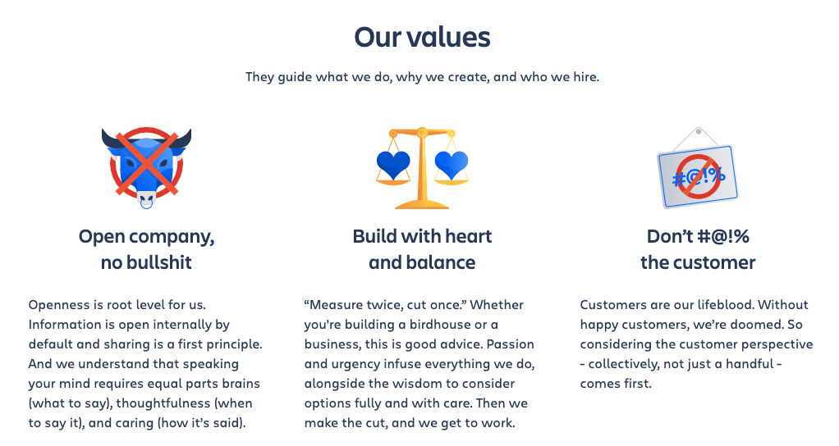

7. Work on The Final Draft

Get wordsmithing help. This is a skill that is difficult to master — if you can, get the help of an expert when it comes to the final stages of refining the language in your values.
You may need to go through this process a few times — draft, meet, discuss, modify, redraft, and repeat — before landing on an interpretation that everyone can stand behind.
It’s okay to take time. The more thoughtful and intentional this process, even if it’s slow, the better.
Remember that if your values aren’t memorable or concise, they won’t serve any purpose. Values should be easy to communicate and easy to remember.

Once you have your final draft and before unveiling your values, think and test how your values hold up:
- Will each value help you make decisions (especially the difficult ones)?
- Are your core values memorable?
- Have you included every single part of your culture in at least one value?
- Does each value speak to at least one desired behavior?
- Are your values congruent with your behavior (when you’re at your best)?
- Do values speak to all employees, regardless of rank and function? Are they universal enough?
- Are they specific and distinct enough so as not to be too ‘vague and general’?
- Can your organization uphold these values in stressful and difficult situations?
- Are you willing to defend these values unequivocally?
Once you’re confident with your values list, alongside their descriptions, it’s time to unveil and celebrate.
Pro tip: Use inspiring and unique words and vocabulary. Our brains are quick to delete or ignore the mundane and commonplace. A phrase like “Donor Service Excellence” is not going to inspire you or your employees. “Innovation” is more boring than “Wild Creativity”. However, don’t fall into creating flimsy slogans and taglines that sound sales-y. Those are not core values.

8. Unveil And Celebrate
It’s time to unveil the fruit of your hard labor!
There are many ways in which you can share your newly created values. You can create a slide show or something more creative like the poster by SEOmoz. The acronym for their values is TAGFEE.
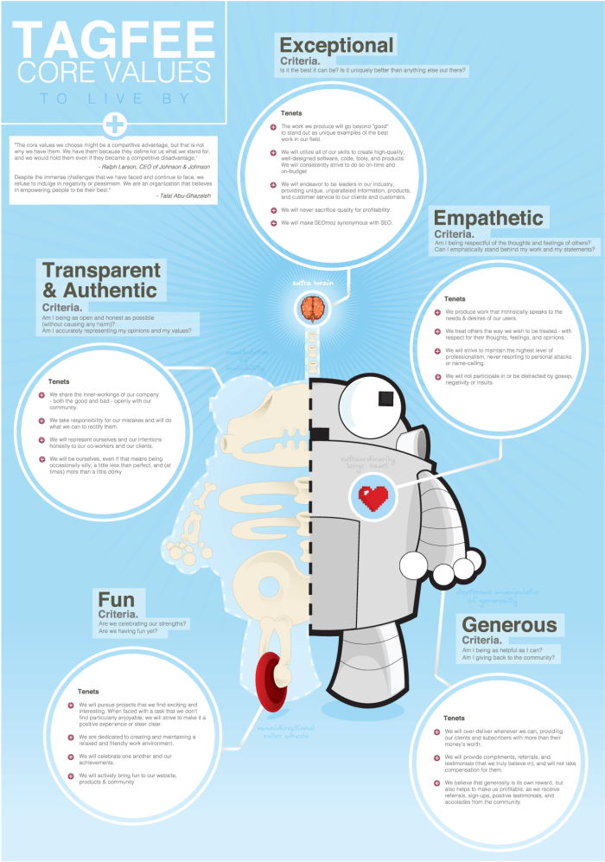
In addition to having something easy to grasp (like the acronym and the poster), it’s advisable to create a document (or a blog post if you want to make the details of your values public) that goes more in detail. Moz did a GREAT job with describing exactly what their values mean to them, complete with examples, tenents, and criteria. Doing this eliminates potential confusion, inconsistency, and makes values very clear and tangible.
Be transparent about the process. Let people know why the final values statement looks the way it looks. What decisions have you made, and why?
Whatever you choose to do, try to create a sense of excitement, buzz, and celebration. This should be an uplifting event for the whole organization!
Throw a big party, showcase employees talking about examples of how they lived that value, create a fun video, and constantly reinforce WHY that value matters to everyone in the organization.

Nonprofit Organizational Values – Bonus Tips

1. Bring your values alive.
Organizational values are a living, breathing thing. They guide how an organization thinks and behaves; they will help you make decisions and form successful relationships. Maintaining your values takes effort, but the rewards are more than worth it.
Your core values should be visible in every aspect of your work: from fundraising and marketing to finance to HR.
Don’t let your values gather dust in a drawer or an employee handbook. Bring them alive. For example, at your quarterly meetings, you can review each core value and give shout-outs to team members who’ve exemplified them.
You can paint them prominently on your office doors or pull them out in blogs, reaffirm them in printed material, such as brochures and annual reports. During goal-setting, frame your goals around values.

2. Integrate your values.

It’s critical to identify any changes you’ll make or practices you’ll adopt to support the integration of your values.
For example, to integrate an “innovation” value, you might set up an innovation award given out during the quarterly review process.
To integrate your “people-oriented” value, you might want to introduce a practice of “mental health days off” for your employees.
Draft a plan for integrating your values. Go one by one to determine how they might become a part of your culture, or how you might build a rewards system that better aligns with them.

3. Revisit and evolve regularly.
Your nonprofit organizational values list shouldn’t be static. Perhaps a few months later you might combine two values to more accurately represent your team and your overall purpose. (This can often happen in the first six months after you’ve determined the values).
However, mission and values are typically not an annual editing issue, so they shouldn’t be revisited too frequently either. Values are long-term foundational attributes.
It’s typical to review values and mission during the strategic planning process, which typically happens formally every three to five years. However, this might not work for every organization.
Take these with a grain of salt and decide what frequency is best for your organization.
Pro tip: Although constantly changing values might not be good, frequently ask yourself how you’re living them as an organization is!

Now, It’s Your Turn
The process of developing core nonprofit organizational values in the right way is neither quick nor easy. But organizations with strong cultures perform better than those without. Although creating and leveraging core values may seem daunting, the impact on your company culture can be tremendous.
Thoughtful, well-implemented nonprofit organizational values can serve as the foundation for a positive, high-performance, and high-impact culture.
Although the process can take time, be confusing, tedious, or downright frustrating – it’s definitely worth taking the time to get everyone on the same page by establishing clear core organizational values, developing a mutual understanding of them, and then bringing them to life.
Choose Donorbox as your donation system and check out our nonprofit blog for more nonprofit resources and tips.

